Health Behavior in School-Aged Children (HBSC) Study in Georgia (Pilot Study)

Introduction

Adolescence is the most important period for physical and psycho-social development. This is the period when individual has diverse needs and problems (1).
Adolescence is generally healthy time of life, but several important public health and social problems either peak or start during these years, for example: homicide, suicide, motor vehicle crashes including those caused by drinking and driving, substance use, smoking, sexually transmitted infections, including human immunodeficiency virus (HIV), teen and unplanned pregnancies, homelessness (2). Frequently, they are victims of social, cultural and religious norms and misconceptions. The problemturns deeper when it is associated with disability or mental instability of adolescents. Globalization made them more vulnerable from one side but more self-dependent and obstinacy from other side. Globalization and the rapid industrialization also influence adolescent health and behavior (3).

Adolescents’ health is centrally placed in the 2030 Sustainable Development Agenda (4). Because it is becoming increasingly clear that promoting and protecting adolescent health leads to public health, economic and demographic benefits and overall well-being of the society. According to WHO “investments in adolescent health bring a triple dividend of health benefits: for adolescents now, for adolescents future life and for the next generation” (5).

Adolescents’health and their rights are challenges for developing countries. Structural and functional changes in adolescents impact their behavior and emotion. Georgia is one of these developing countries. The country is facing transition from Soviet culture. Absence of adolescent friendly healthcare services influence negatively adolescents’ and youths’ health and increase the burden of adolescents mortality and morbidity in the country.
Today Georgia has opportunity to improve adolescent’ health and well-being as the country took responsibility to achievethe 17 SDGs and their 169 target and as each of which relates to adolescent development, health or well-being directly or indirectly.
The presented pilot study was the first trail in Georgia to gain new insight into, and increase our understanding of young people’s health and wellbeing, health behaviors and their social context.

HBSC is a cross-sectional research study conducted in collaboration with the World Health Organization (WHO) Regional Office for Europe. The HBSC international survey runs onan academic 4-year cycle and in 2013/2014 there were 44 participating countries and regions. The overall goal of the study is to improve health and welfare of young people through revealing a wide range of factors affecting their health and development, including health, education, social context, family and personal determinants.
Chapter I

Purpose of the Study and Research Methods

According to the National Statistic Office of Georgia, in 2016 at the beginning of the year adolescents in the country were 11.3 percent of the total population (6). There are a lots of health related issues that adolescents as well as youth are facing in Georgia among them are: drug and alcohol abuse, smoking, STI/HIV/AIDS, early marriage and unwanted pregnancies, mental health, violence, trauma, stigma and discrimination.

To collect information about adolescent health, behavior and development should be one of the main strategic goals for the countries. With this purpose the National Center for Disease Control and Public Health of Georgia (NCDC) in close collaboration with WHO European and country office implemented pilot study in 22 schools of Georgia and decided to join the international HBSC research network.

The pilot HBSC study was first time done in Georgia in spring of 2017 and the aim of the study was to obtain new evidence and increase the level of awareness in relation to health behaviors, health and lifestyle of adolescents in their social context. The pilot study had as a scientific meaning also to validate questionnaire and prepare interviewers for the next field work.

The mandatory module of the international protocol to develop the national questionnaire was used for the study. The national research protocol was approved by the Ethics Committee of NCDC.

Objectives of the study
- Initiate pilot study, and support national and international research on health, wellbeing, health behaviors, health and social context of school-aged children;
- Develop of theoretical, conceptual and methodological research in health, wellbeing, health behaviors and social context of health in school-aged children that is relevant for Georgian context;
- Collect relevant evidence on school-aged children and monitor the health, wellbeing, health behaviors, health and social context of school-aged children in member countries;
- Validate study instruments and identify topic for the first full HBSC survey;
- Establish and support a network of international experts in this field.

Target groups of the study were adolescents/children of 11, 13, 15 years of age, enrolled in the education system.

The sample of the pilot study included: 1712respondents form 22 secondary schools, 22 clusters (study grades/groups)

Table 1: Composition of the pilot HBSC study sample, 2017

 |  | Age |  |  | Total
 |  | 11 yearsold | 13 yearsold | 15 yearsold | Total
Gender | Girls | 232 (52%) | 316(58%) | 379(52%) | 927
Gender | Boys | 217 (48%) | 234( 42%) | 339 (47%) | 790
Total |  | 449 | 550 | 718 | 1717

Sample: stratified, randomly selected, two-staged

Stratification criteria: 22 secondary schools were chosen from the list provided by the Ministry of Education and Science (2321 total secondary schools). According to the HBSC survey methodology the following age groups were involved in the pilot study: 11, 13, 15 year old adolescents (5th, 7th, 9th grades), from the rural and urban settings. Study was done in Georgian Language.

Data collection: The self-filled questionnaire was applied as a method of data collection. The questionnaire was developed based on mandatory modules, translated and adapted to Georgian language. Separate questionnaire was used for boys and girls. Data were collected with the active participation of interviewers from NCDC. Data was collected in the selected schools and selected grades from 30 April till 25 of May, 2017.

Data processing and analysis: According to the HBSC study protocol, data was processing and analyzed in the SPSS program

Chapter II Status of Adolescent Health
II.1. Self-assessment of health status

The number of respondent girls who believe that their health status were excellent 4% higher than boys among 11-year olds. But share of boys among 13 and 15 year olds who thought that their health is excellent were more than girls by 12.4% and 7.6% respectively.

Share of those who negatively assess that their health status was following: among 11-years old was 2%, 13-year olds was 23.2% and 15-year olds 2.8%.

Figure 1: share of adolescents who positively assess their health status (good,excellent)

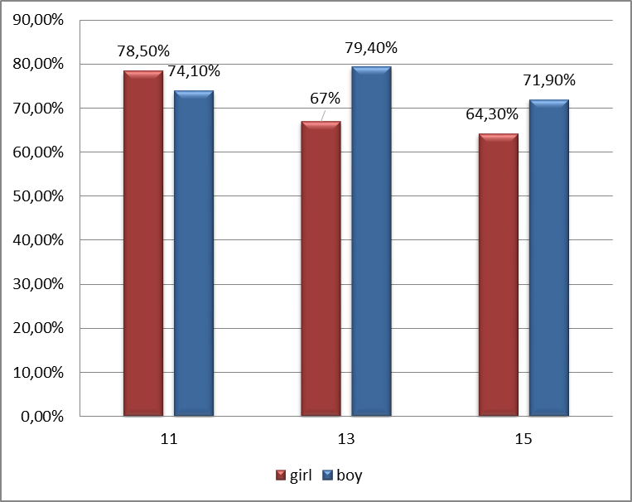

II.2 Self-assessment of wellbeing (life satisfaction)
Share of study respondents who assessed their life as prosperous were more than 48%, and those who referred to as suffering was 2.3% and scored lower their life were 0.9% .
Figure 2: Share of adolescent who assess their life as prosperous

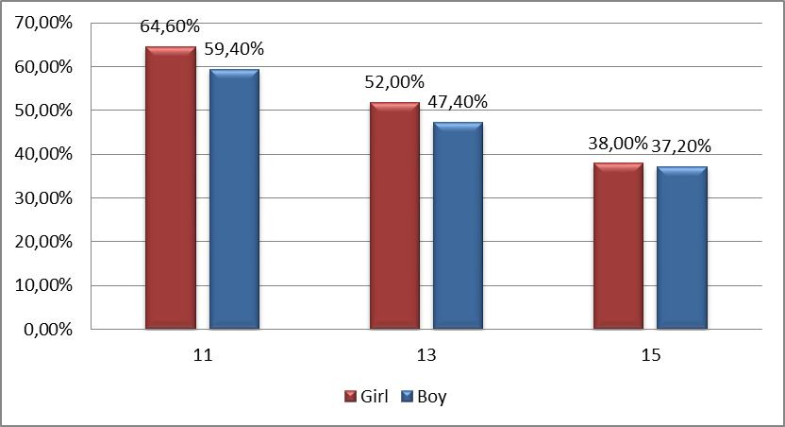

II.4. Body image

51,9% of respondents believed that their body weight is adequate, 21.5 % thought they are “more thin than adequate” and 17.7% stated they are “thin”. Share of respondents who believe that their body weight is adequate is increasing with age, from 12.6% (11-year olds) to 21 % (15-year olds).
13 and 15 –year old study participant boys believed that they have adequate body weight.
5.1% of respondents thought that they are “too thin”, and 21.5% believed that they were overweight and 1.2% stated that they are obese.
Figure 3: Share of girls and boys in different age groups, who assessed their body weight as adequate

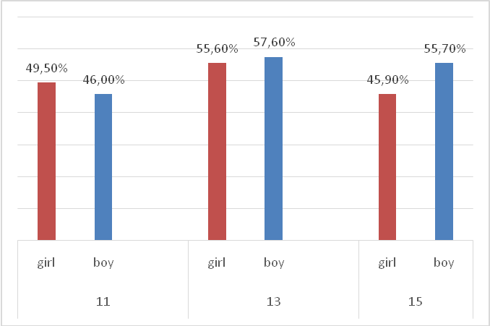

II.5. Pubertal development (girls)

The majority of 15 year old girls (66.1%) reported that their first menstruation came between 9 and 15 years of age. The average age for the first menstruation is 13 years.

Figure 4: Share of adolescent with menstruation, by age groups
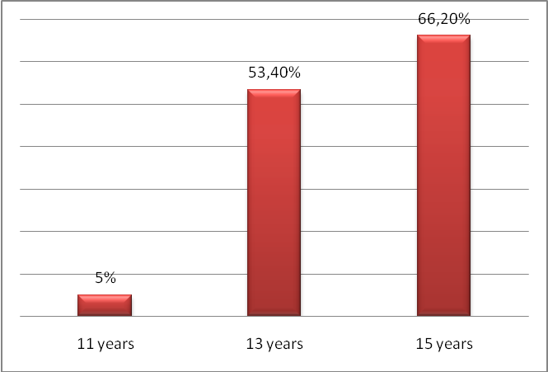

II. 6. Subjective signs of disease

About 5% of adolescents mentioned that they had mood disorders or head and back pain during last six months.
Every fourth of participants stated that they experienced abdominal pain and every fifth stated that they had sleeping disorders and every sixth had dizziness. The frequency of health complaints increases with age.

Figure 5: frequency of adolescent reporting of signs of disease

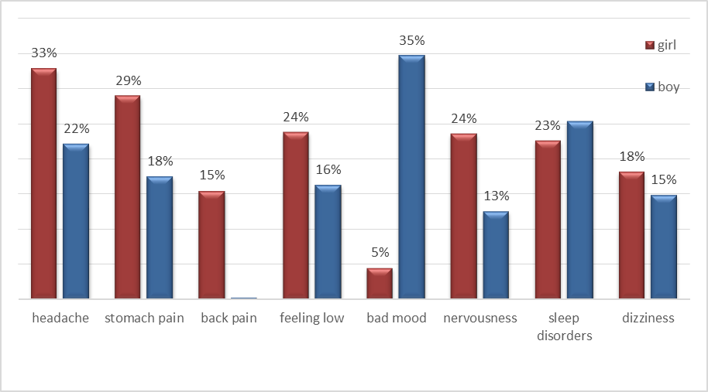

II.7 Trauma and accidents
Every second boy and every fifth girl from survey participants were wounded/injured over the last year. Among them 15.3% repeated accidents/trauma and needed to seek medical care, one stated that had accidents/trauma and needed serious medical care. 14.5 % respondents of the study reported that they had suffered two or more accidents.

Figure 6: Share of adolescents who have been injured or have been in accidents two times or more often during the last year

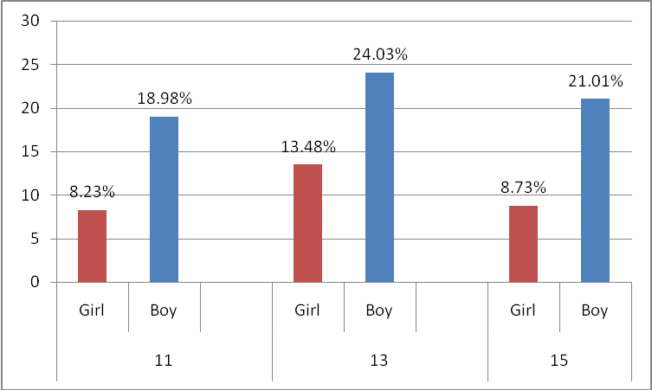

Chapter III Health Behavior in Adolescents r

III.1. Food behavior
Most of the study participants mentions that they are having breakfast nearly every day, among them 45.5% stated having breakfast every weekday, only 15 % of then don’t have breakfast at all. Study also clarified those girls more often than boys do not have breakfast during the week (24% and 21% respectively).More frequently (in 63% cases) adolescents have breakfast on both weekend days. However, in 11% of cases they do not have breakfast even on weekends. Only 12% of respondents have indicated eating fruits daily and (10%) eating fruits once a week or less often. Only 10% of respondents have indicated eating vegetables daily and (20%) eating vegetables once a week or less often. Girls eat fruits and vegetables (12.9%) more often than boys (9.8%)

Figure 7: Share of girls and boys consuming fruits and vegetables daily

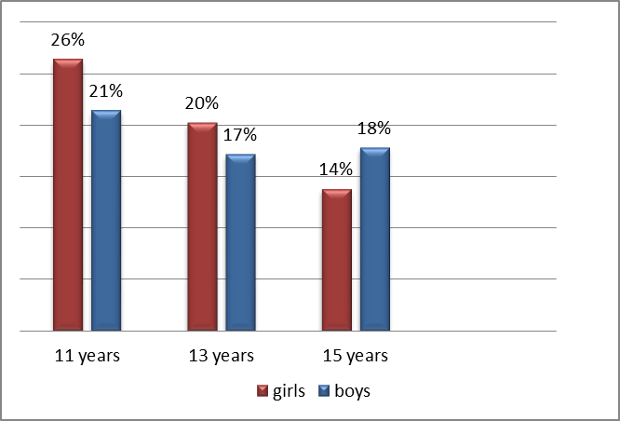

30% of adolescents have indicated eating once a day and more sweets (candy or chocolate), 21% of them drink Coca-Cola or other sugary soft drinks once a day or more often, without significant differences by gender.
Approximately 8.9% of respondents have indicated being on a fasting diet. 10% of girls have indicated being on a fasting diet and 7% of boys.

2. Dental hygiene

The absolute majority of respondents (94%) have indicated brushing their teeth every day, from them 58% stated that they are brushing teeth more than once and 36% half of them brush teeth once a day.

Figure 8: share of adolescents brushing their teeth more than once a day

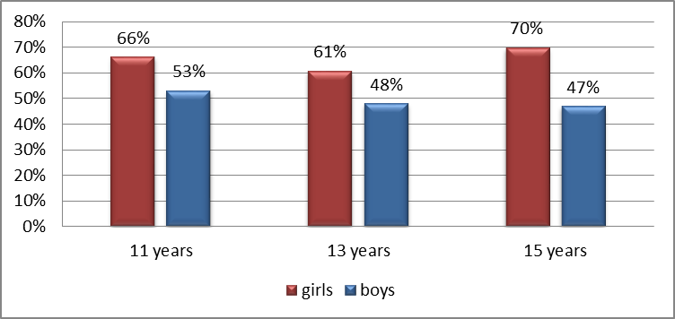

Figure 9: share of adolescents brushing their teeth once a day

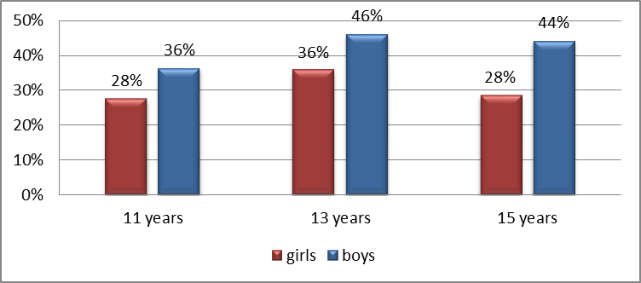
5% of respondents have indicated brushing their teeth even less often. Boys have reported such behavior more often than girls (7% versus 5%, respectively), and with increasing age – less often (10% in 11-year olds, 6% in 13-year olds, 7% in 15-year olds). Only 1% of participants indicated that they never brushed teeth.

- Physical activity
Only 16% of adolescents have practiced physicalactivityforatotalofminimum60 minutes a day during the last week, and 14%-hadnophysicalactivityon any day.

Figure 10: Share of adolescents practicing daily physical activity at least one hour a day during the last week

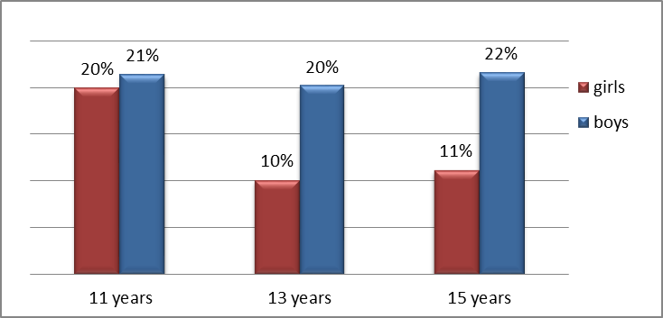

65 % of respondents (55% girls and 77% boys) have indicated engaging in daily physical exercise in their spare time, till experiencing shortness of breath or sweating, 2-3 times a week and more often, with the same trends by gender and age.

Figure 11: Share of adolescents practicing daily physical activity at least one hour a day during the last week

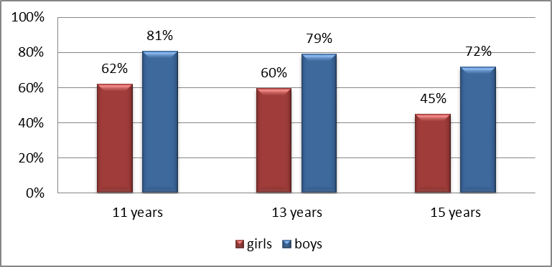

4. Sedentary behaviour

50% of respondents have indicated spending time watching TV, videos (including YouTube or other similar programs), DVDs and other entertainment programs, which use screen projection, 2 hours a day and more during weekdays, and 68% - during weekends.
31% of adolescents have indicated using daily, for 2 hours and more, information technologies for entertainment for socializing and studying during weekdayand 48% - during weekend.
Figure 12: Share of adolescents using daily, for 2 hours and more, information technologies for entertainment

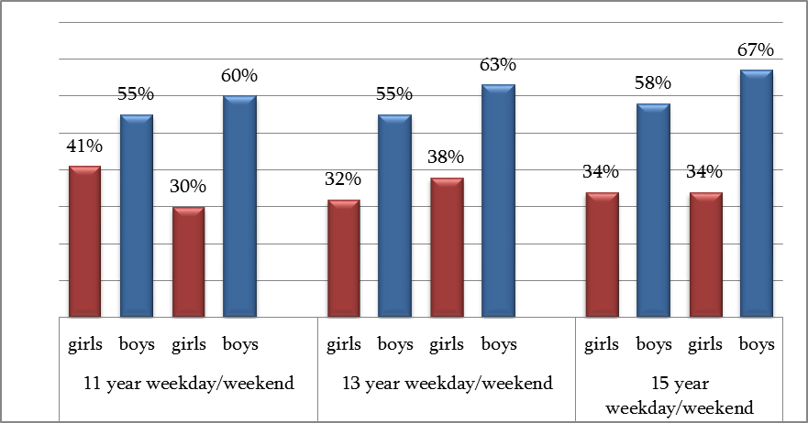

41% of respondents have indicated using daily,2 hours or more, information technologies for socializing and studying during weekdays, and 51% - during weekends.
Figure 13: Share of adolescents had use over 2 hours a day information technologies for socialization and studying

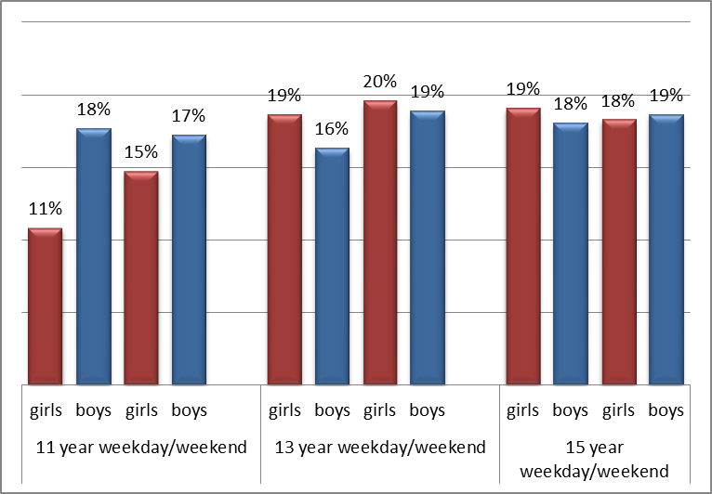
Chapter IV Risk Behaviors in Adolescents
IV.1 use of psychoactive substances, smoking
Every fourth adolescent (every fourth among girl and every fifth of boys) have tried smoking during their lifetime, and one in ten adolescents (12.2%of boys and 7.4% of girls) respondent has tried it during the last month.

As was expected from the age of 15, the share of adolescents who smoke starts to increase significantly compared with previous age groups. Every thirteenth of indicated that started same-year olds adolescents stated that they already started smoking.
Figure 14: Share of Adolescents Indication Smoking Once a Week or More
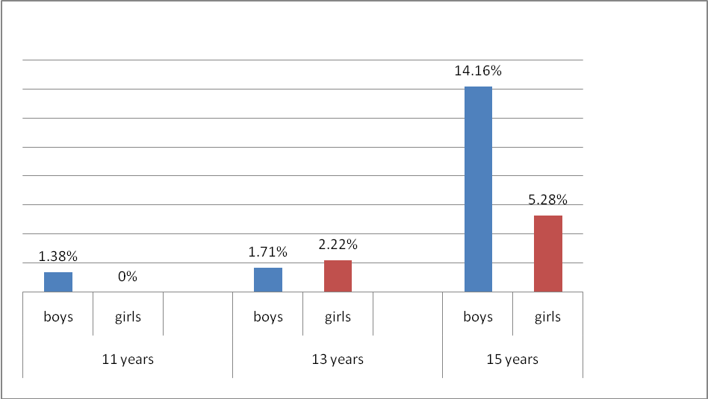
IV.2 Use of psychoactive substances, cannabis
3,74% of respondents have indicated using cannabis (marijuana, hashish, weed) during their lifetime, and 2,45% - recently, in the last month. Boys reported 9 times more often than girls experimenting with cannabis during their lifetime. Boys 4 times more use marijuana than girls during last month. 3,74% of 15-year olds adolescents mentioned that they use marijuana.

IV.3 Use of psychoactive substances, alcohol
Every seventh from 11-year olds consumed alcohol lifetime, at least once during last 30 days. Alcohol consumption is increasing with age, for example among 13-year olds every fourth and every second among15-year olds stated alcohol consumption during last month. Study findings showed that boys more consume alcohol than girls.
Most consumed alcohol is beer among 11-year olds, 13-year olds and 15-year olds 17.9%, 41% and 56.5% indicated consumption of beer respectively.

Figure 15: Share of adolescents consuming different types of alcohol once a week and more often

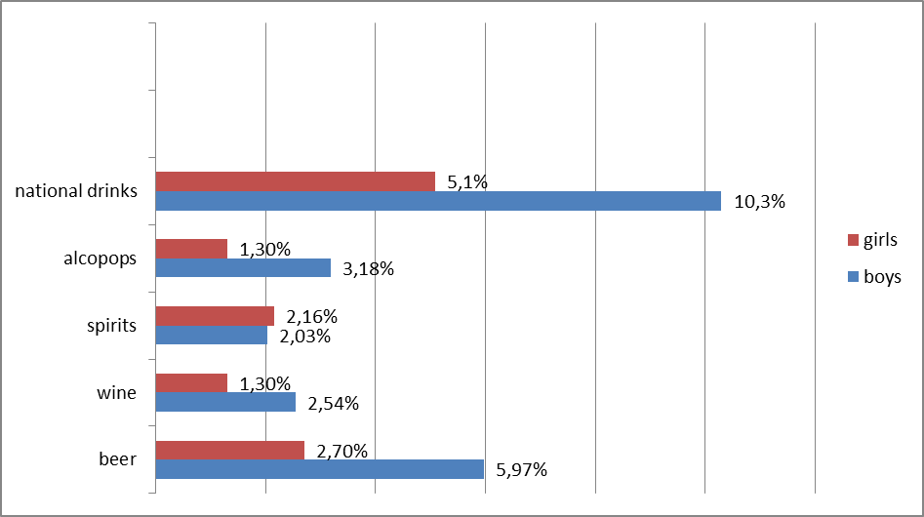
Every sixth in 11-year olds and every second in 13-year olds have gotten drunk at least once in their life. This share is highest among 15-year olds (60.4%).21,5% of 15-year olds and 14,4%of 13-year old and 7,4% of 11-year olds have gotten drunk at least once in their life.

Figure 16: share of adolescents who have gotten drunk at least once

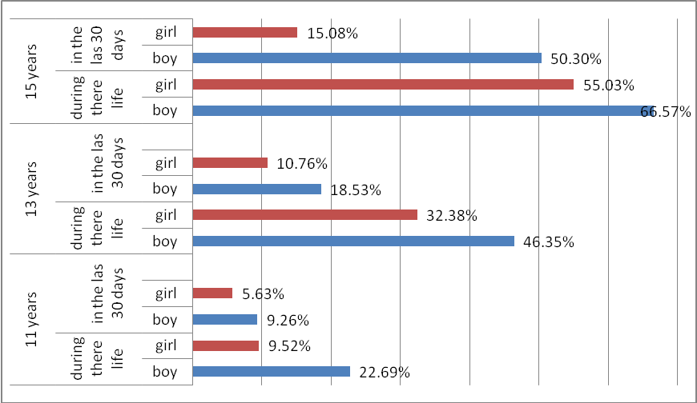

Every seventh of adolescents started alcohol consumption at age 11 and earlier. Some of them also mentioned that at age 13.
IV.4 Sexual behavior
39.35% of 15-year olds reported having had a sexual intercourse. Among boys the share of those who reported having a sexual intercourse is higher than among girls.

Figure 17: share of adolescents having share of adolescents having sexual contact

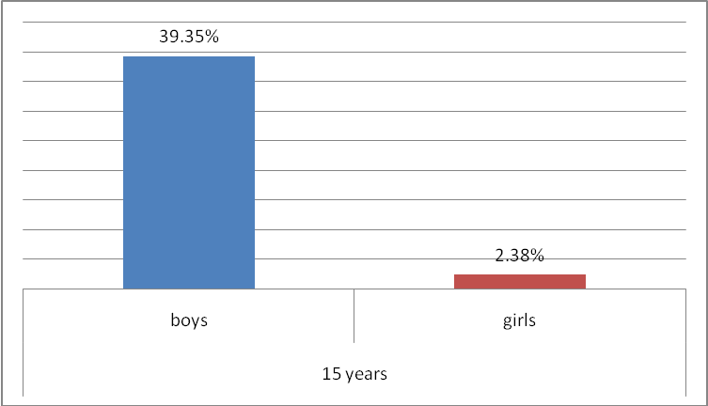
8,29% of respondents who had sexual contact 14.8%reported the first intercourse at the age of 11 or earlier, 9,9% at the age 12, 12,7% at the age 13, 32,4% at the age 14 and 30.9 at the age 15. Only one girl reported use of modern contraception and there was only one case of condom use among male respondents.

IV.5 Physical violence
11,3% of respondents indicated their involvement in a fight in the last 12 months. Boys reported involvement in a fight in the last 12 months 3 times more often than girls.

Figure 18: Share of Adolescents involved in Fights twice or more often in the last 12 months
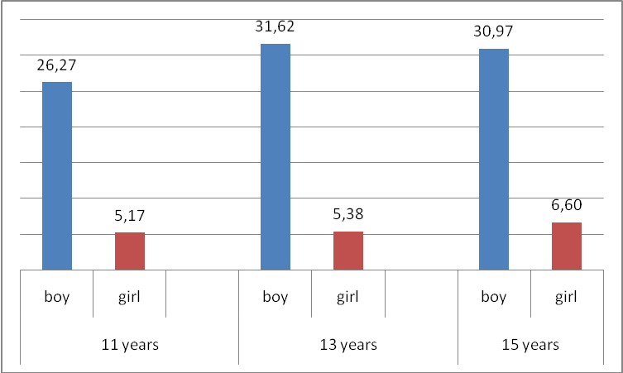
17% of respondents have been repeatedly involved in physical aggression in the last year among them boys were more than girls (30% and 6% respectively). Involvement of boys in physical aggression is increasing with age.

IV.4 Harassment
Every eight respondents reported being among those who have intimidated /aggressed other students at school and every twelfth respondents have reported that they were intimidated / mocked / aggressed in school during the last two months. Share of boys with aggressor roles increases with age and the highest at age 15. Girls more frequently are victims of bulling than boys. The biggest share of harassment was detected among 11-year olds respondents.

Figure 19: Share of Adolescents Involved in bullying
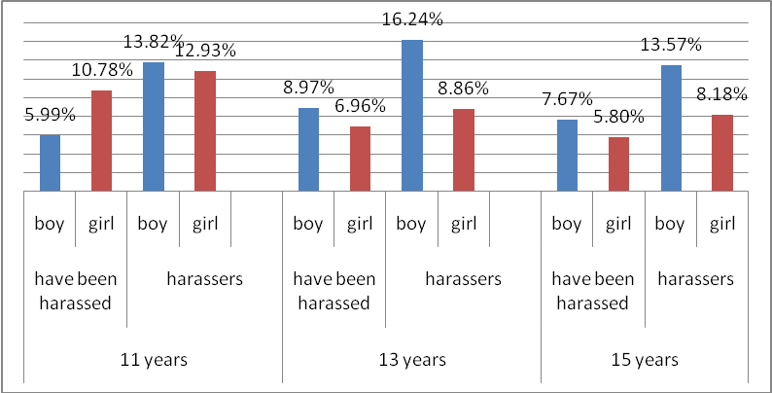

V. Social Context
V.1.1. Family, Communication and relations
The study showed the value of family as a key factor of adolescent health protection and development. Most of the respondents stated that to talk with mother is “easy”. Share of participants among age groups who talk easily with mother than father were following: 18.3%11-year olds, 23% 13-year olds, 29% 15-year olds. Among them who can talk easily with step-mothers or step-fathers was more boy than girls.

l Inequalities
V.1.2. Family. Social Inequalities
61,6% of respondents mentioned that they were living with both parents. 37.3 of study participants were living with only mothers and 1.1% lived with only fathers.
Figure 20: Share of respondents living with both parents or with one parent only
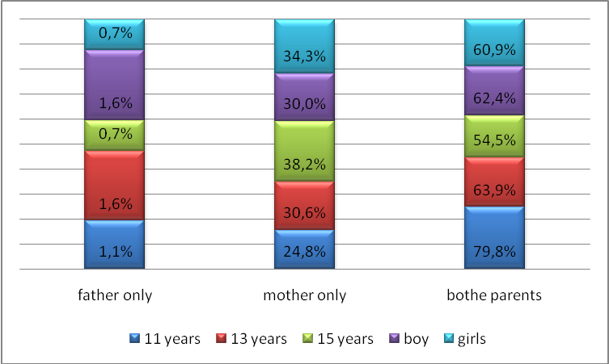
One of third respondents’ fathers’ had a job (32.3%). Share of study participants whose father had a job was among 15-year olds (71.5). 56.6 % of study participants’mothers had job and this share is higher among 15-year olds (61.6%).
Family members of 24.4 % respondents had no a car, minivan or truck. 36.6% of them had one car and 18% had more than two cars. 15% of them had their own room and 61.6% had no.
5.8% of respondents had no own computers, 37.3% had one computer and 36.2% had two. 10.7% of study respondents had not traveled with their family for vacation with family during last 12 months. 23,4% of them traveled once and 45,2% more than twice.

Figure 21: Distribution of respondents according to their family's financial status

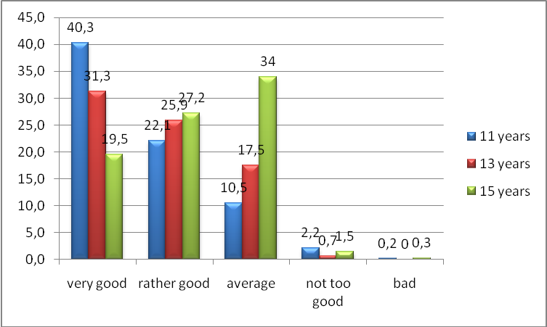
Adolescents’ perception about their living standards were following: 25.4% of study participants stated as high, 22.6% as average and 0.10% as a very low.
School
The number of respondents who liked schools increasing by age. Among them share of girls are more than boys.
Table 2: The number of respondents who said they liked school.
Age | Girls | Boys
11 | 198 (54%) | 167 (46%)
13 | 259 (60%) | 174 (40%)
15 | 293 (58%) | 233 (42%)

Some of adolescents felt stressed in the school.

Figure 22: Share of adolescents who are stressed in school

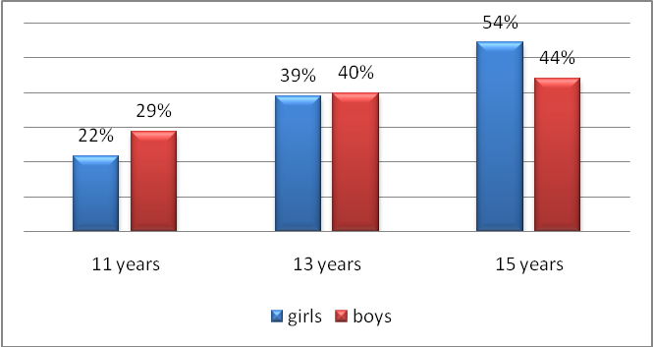

The number of respondents, who believed that school teachers think that their performances as very good increasing among boys by age but this number is decreased among girls.

Table 3: The number of respondents who believe that school teachers think of their performances as very good

Age | girls | boys
11 | 105 (60%) | 69 (40%) | 174
13 | 85 (61.5%) | 53 (48.5%) | 138
15 | 93 (55%) | 75 (45%) | 168

The share of those who agree and strongly agree with the statement that class- mates like to spend time together is maintained more or less the same in all age groups.
Table 4: The share of those who agree and strongly agree with the statement that classmates like to spend time together
Age | girls | boys
11 | 69% | 71%
13 | 63% | 67%
15 | 70% | 63%

The study also revealed what are the relationships with classmates of respondents. Every second respondents meets with classmates every day after school. Girls are frequently meets with each other than boys. And with increase of age this share is increasing. Girls are more frequently stated that they love to spend their free time with classmates in schools. Share was the lowest among 11 –year olds boys and girls.

Most of respondents believed that the peers accepted them as they are. Among boys there are almost no significant differences by age. 11- and 13-year old girls who believe that they are accepted by peers are higher than among 15.
Table 5: Accepted by peers as they are
 | Girls | Boys
11 years | 75% | 72%
13 years | 68% | 74%
15 years | 69% | 69%

The percentage of respondents who believe that their classmates are kind and friendly decreases with age were following: 69.6% in 11-year olds, 65%% in 13-year olds, 66.6% in 15-year olds. More girls than boys believed their colleagues to be good and friendly at all ages.

Further recommendations
- Develop comprehensive strategies to promote adolescent health and well-being.
- Introduce Adolescent Friendly Approaches into the Health, Education, Social systems.
- Sensitize the general population, government, civil society, mass media, private sector to promote and protect the health of adolescents.
- Introduce Healthy Lifestyle topics into the State Education Curriculum.
- For better understanding of the current issues in such fields like adolescents nutrition, violence among adolescents, risk behaviour, health status, health-seeking behaviour, mental health and sexual behaviour further studies are needed.

References:
1. Geneva Foundation for Medical Education and Research. NGO Makes Case for Sex Education in School. 2014. Available from: http://www.gfmer.ch/SRH-Course-2014/adolescent-health/pdf/Tanzania.pdf
2. Geneva Foundation for Medical Education and Research.2014. Call to Make Sex education Mandatory in QLD Schools.Available from: http://www.gfmer.ch/SRH-Course-2014/adolescent-health/pdf/Australia.pdf
3. Geneva Foundation for Medical Education and Research.2014. Communities Mobilizing for Adolescents’ sexual and reproductive Health: the case of Guatemala. Available from:http://www.gfmer.ch/SRH-Course-2014/adolescent-health/pdf/Guatemala.pdf

4. WHO. 2017. Sustainable Development Goals. Available from: http://www.who.int/sdg/en/

5. WHO. 2017. Maternal, newborn, child and adolescent health. Available from: http://www.who.int/maternal_child_adolescent/topics/adolescence/why-invest/en/

6. National Statistics Office of Georgia. 2017. Population. Available from: http://www.geostat.ge/index.php?action=page&p_id=473&lang=eng

